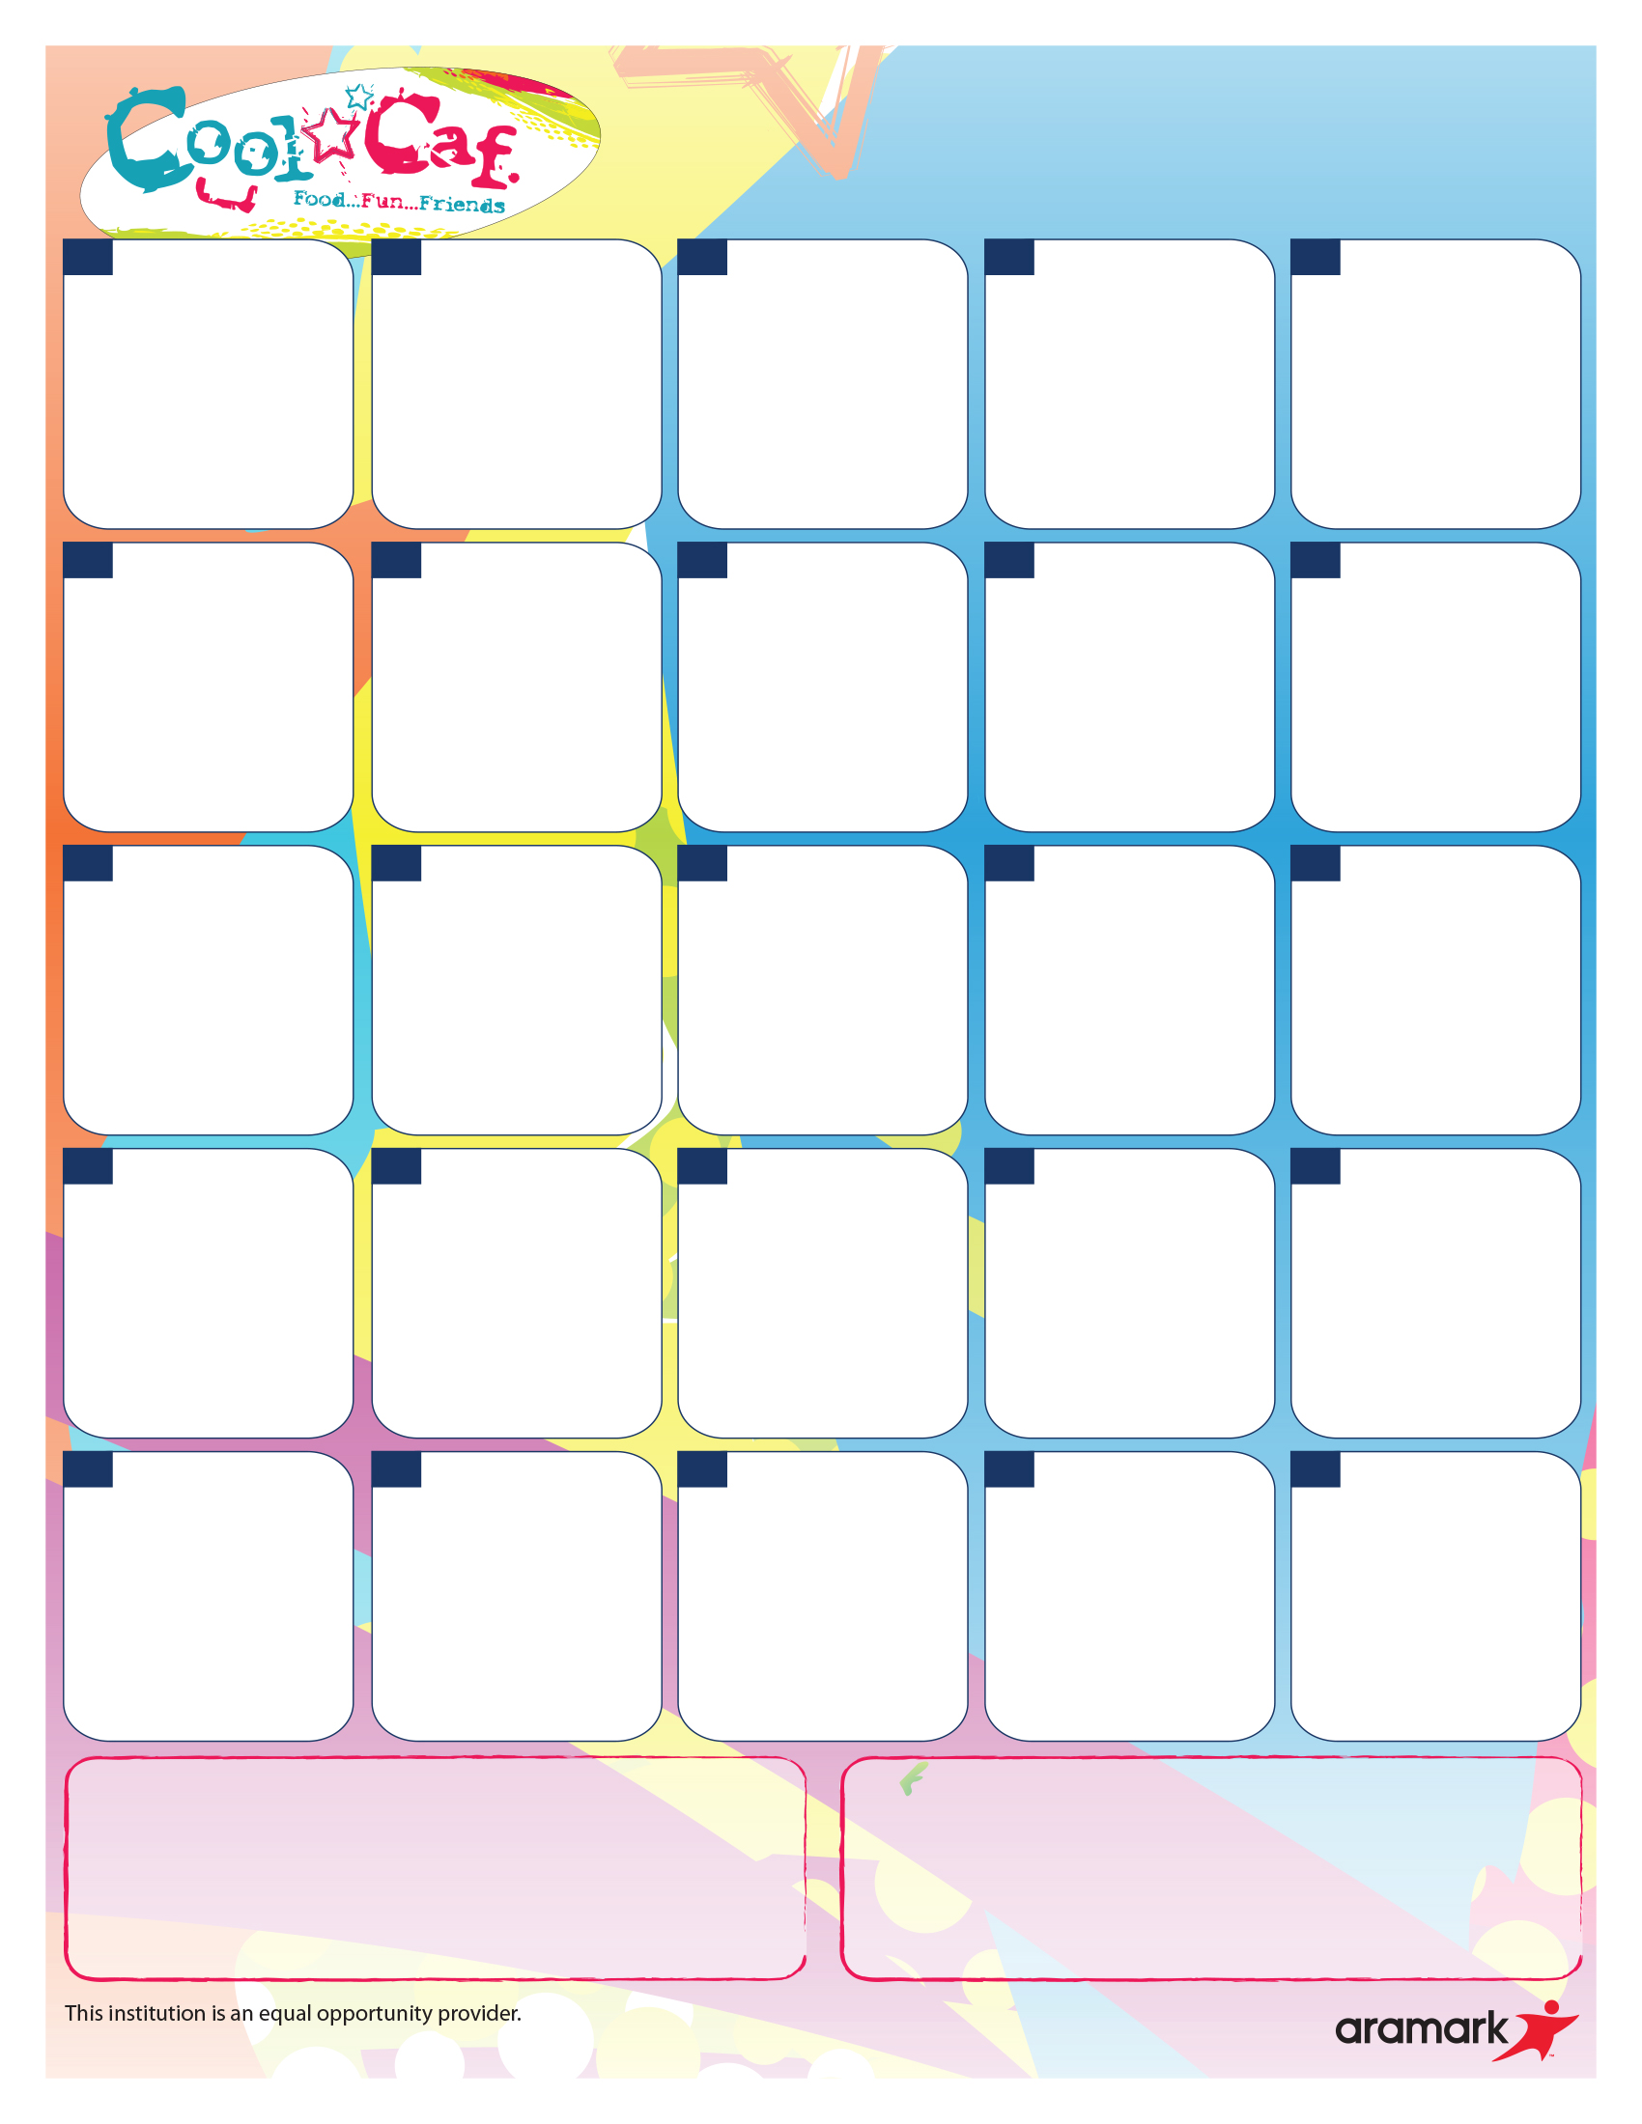

**26**

**27**

**28**

**29**

**30**

**19**

**20**

**21**

**22**

**23**

**12**

**13**

**14**

**15**

**16**

**9**

**8**

**7**

**6**

**5**

**2**

**1**

Milk offered with breakfast

Cold Option includes:

Assorted Cold Cereals w/ Cheese Sticks

Cereal Bars w/ Cheese Sticks

**Avondale / Vision Breakfast**

**March 2018**

**Avondale:**

**Breakfast Pizza**

**Vision:**

**Muffin w/ Cheese Stick**

Assorted Fruit

**Trix Yogurt**

**& Animal Crackers**

Assorted Fruit

**Cinna-Mini**

Assorted Fruit

**Muffin w/ Cheese stick**

Assorted Fruit

**French Toast**

Assorted Fruit

**Breakfast Slider**

Assorted Fruit

**Breakfast Bar w/ Cheese stick**

Assorted Fruit

**Pancake**

Assorted Fruit

**Cinnamon Bagel**

Assorted Fruit

**Avondale:**

**Breakfast Pizza**

**Vision:**

**Muffin w/ Cheese Stick**

Assorted Fruit

**Trix Yogurt**

**& Animal Crackers**

Assorted Fruit

**Avondale:**

**Breakfast Pizza**

**Vision:**

**Muffin w/ Cheese Stick**

Assorted Fruit